EXP- 2(Linux)

Aim : Understand Basic Linux commands

Commands:
- date
date – displays current date with day:month:hh:mm:ss:year
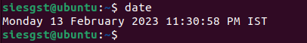
- cal
cal – diplay the calender highlighed with current date.
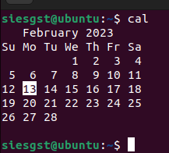
- pwd
pwd - Display name of current directory
The command >pwd is used to display the full path name of the current directory.
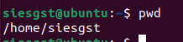

- cd
cd - Switch to another directory
To switch to another directory, the command cd is used.
Example | Description
cd | Will place you in your home directory
cd / | Will move you to the root directory
cd /etc | Will move you to the /etc directory
cd ../ | Will move you back one directory

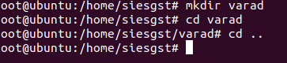

- mkdir and rmdir
mkdir and rmdir - Create/Delete directories
The command mkdir is used to create a new directory.
The command rmdir or rm -r is used to delete a directory or directories.
Examples | What it does
mkdir mydirectory | Will create a new directory named 'mydirectory'
rmdir existingdirectory | Will delete the existing directory named 'existingdirectory'
rm -r existingdirectories | Will delete the existing directory named 'existingdirectories' and all directories and files below it.

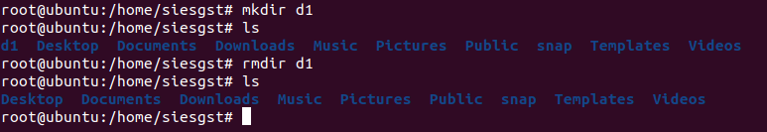

- ls
ls - List the Contents of a directory
The command ls is used to the contents of a directory.
Options | What it does
-l | long listing
-R | list current directory and all other directories within current directory
-a | list hidden files
-CF | list in column format and append '*' to executable files, '@' to symbolic linked files, '/' to directories
-r | list in reverse alphabetically order
-t | list more recent accessed files first
filename(s) | Values to match
Examples | What it does
ls | only list file/directory names in current directory
ls -l | list all file/directory information in current directory(long version)
ls -R | list all files in current directories and below
ls -lt | list all files, sorted by most recent accessed first
ls -lt /etc/rc* | list files in the '/etc/ directory, only starting with 'rc' and sort results by most recent

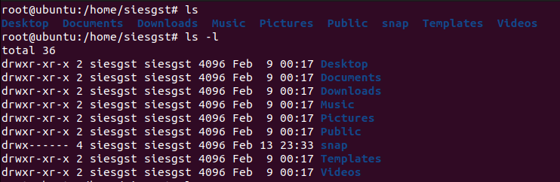
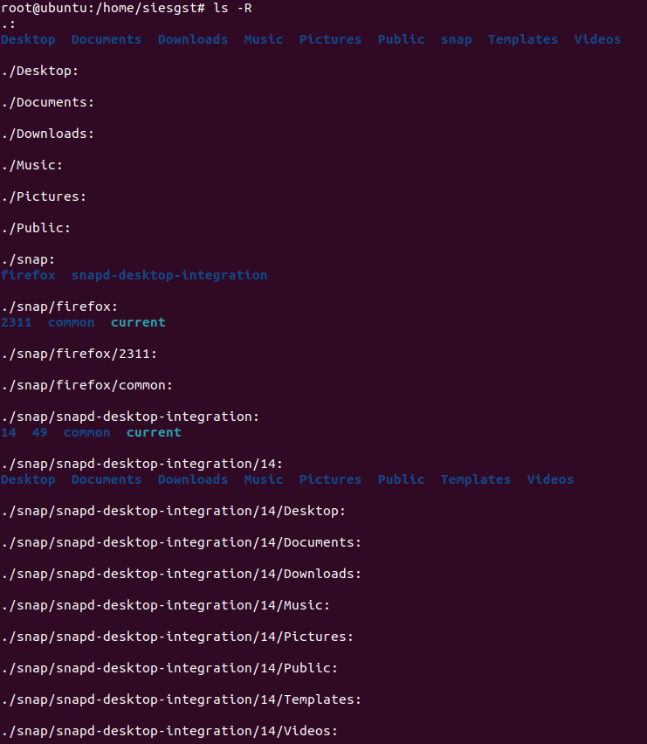
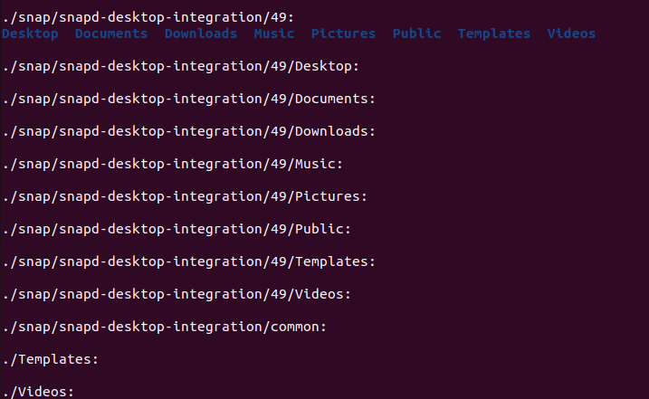

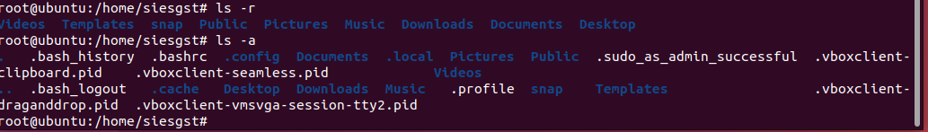

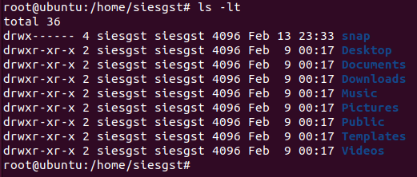

- man
man-display manual for given command
eg. $man ls
The command man is used to learn given command options.
Examples | What it does
man ls | Manual page for ls command
man cat | Manual page for cat command

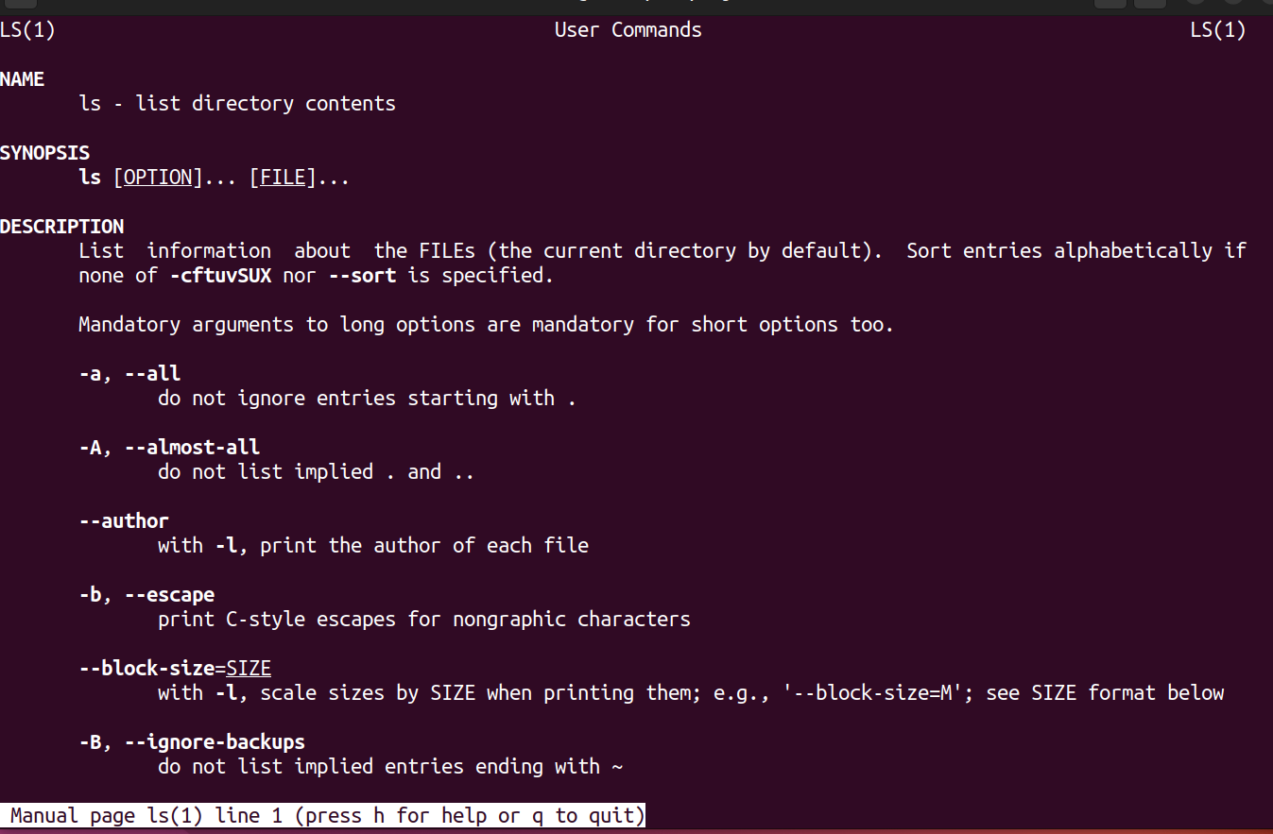

- Cp
cp - Copy files
To copy a file, the command cp is used
Example: cp oldfile myfile - Will copy the existing file 'oldfile' to a new file 'myfile'
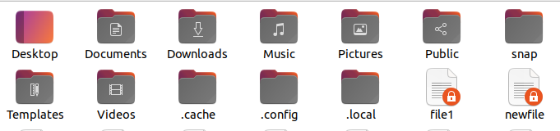
9. mv
- Rename files
The command mv is used to rename a file
Example: mv myfile yourfile - Will rename the file 'myfile' to 'yourfile'
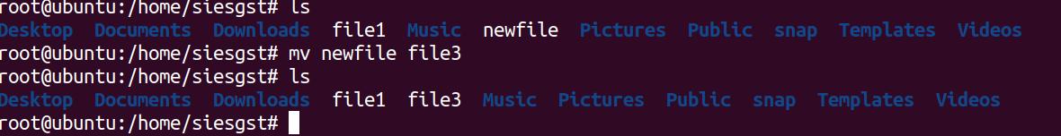
- rm
rm - Delete files
Examples | What it does
rm myfile | remove the file 'myfile'
rm -i abc* | prompt to remove each file in current directory starting with 'abc'
rm abc* | remove all files in current directory starting with 'abc' automatically

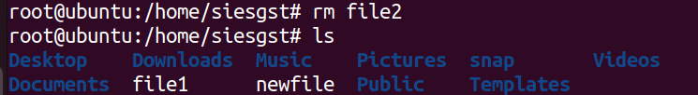
- wc
wc - Count the number of lines or characters
The command wc is used to count lines, words or characters in a file or piped results from another command.
Options |  | What it does
-c |  | Number of characters
-w |  | Number of words
-l |  | Number of lines
filename |  | file name(s) to use
Examples | What it does
wc xyz.txt | Lists the number of lines, words and characters in the file xyz.txt

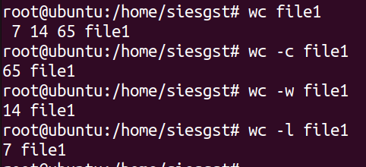
- file
file - Display Type-of-File Description
eg. file xyz.txt
xyz.txt: ASCII text
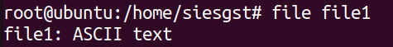
- cat
cat - concatenate files
The command cat is a multi-purpose utility and is mostly used with TEXT files.
- Create a new file and optionally allow the manual entry of contents
  - cat >[filename]
  - Example: cat >myfile will create a file named myfile and allow you to enter contents.
  - Press Control-D to exit entry mode.
  - WARNING: If "myfile" already existed, this command would replace the old file with the contents of the new file.
- Combine text files
  - cat file1 file2 >newfile - This will combine file1 and file2 into newfile.
- Dissplay the contents of a file
  - cat myfile
- Delete the contents of a file
  - cat /dev/null >myfile
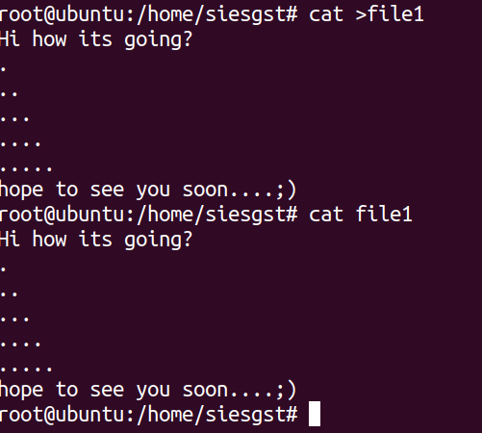

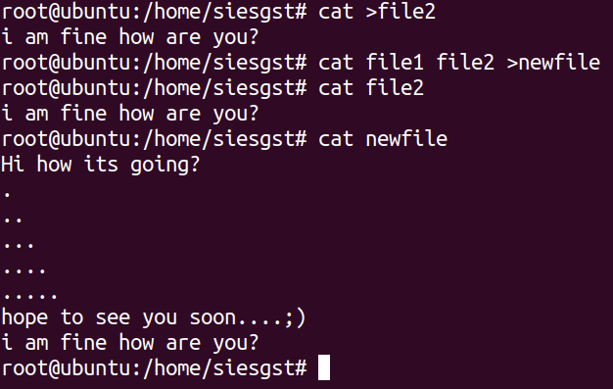

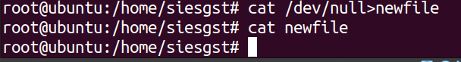

- more
more -print file one screenful at a time
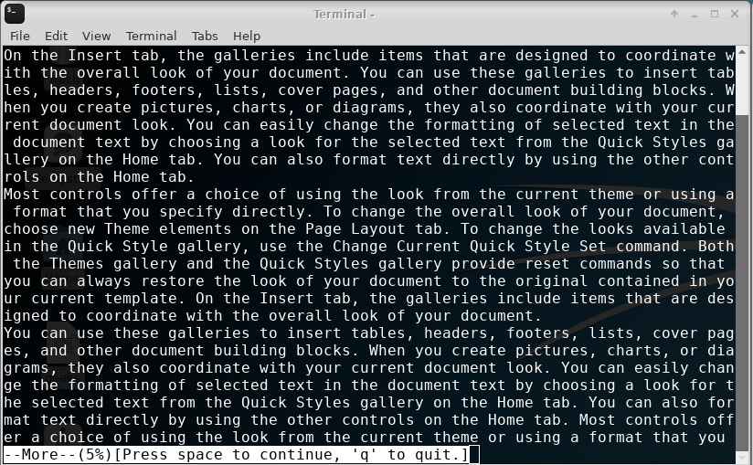

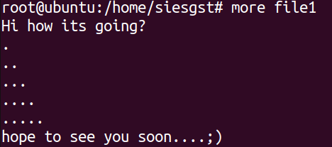
- grep
grep -print only those lines that have the specific character string in the file.

Eg. $grep -i "UNix" geekfile.txt
Output:
unix is great os. unix is opensource. unix is free os.
Unix linux which one you choose.
uNix is easy to learn.unix is a multiuser os.Learn unix .unix is a powerful.
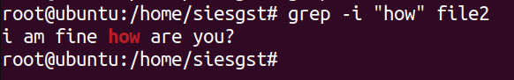

- echo
echo -echos the specified string

Examples | What it does
echo hello | Echos hello on screen

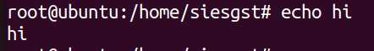

- sort
sort – sort lines of text files
$ sort file.txt
Output :
abhishek
chitransh
divyam
harsh

Options | What it does
-b | Ignore leading blanks
-d | Consider only blanks and alphanumeric characters
-f | Fold lower case to upper case characters
-r | Reverse the result of comparisons
-m | merge already sorted files; do not sort
-i | consider only printable characters
-g | compare according to general numerical value
-n | compare according to string numerical value

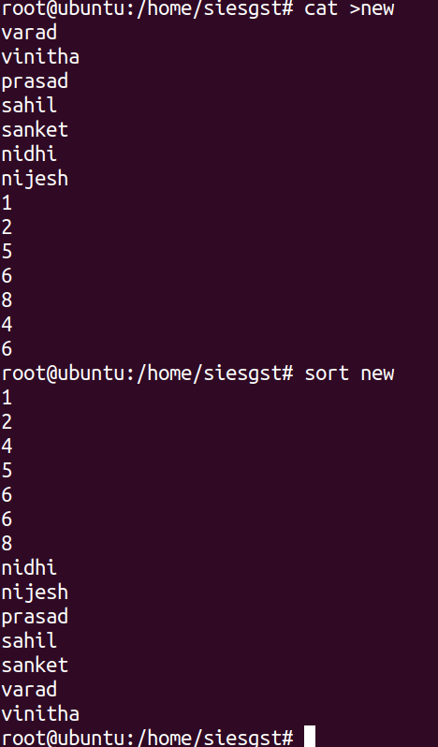

Conclusion: The experiment was performed successfully and student got to know and understand the concept and basic commands of linux.

